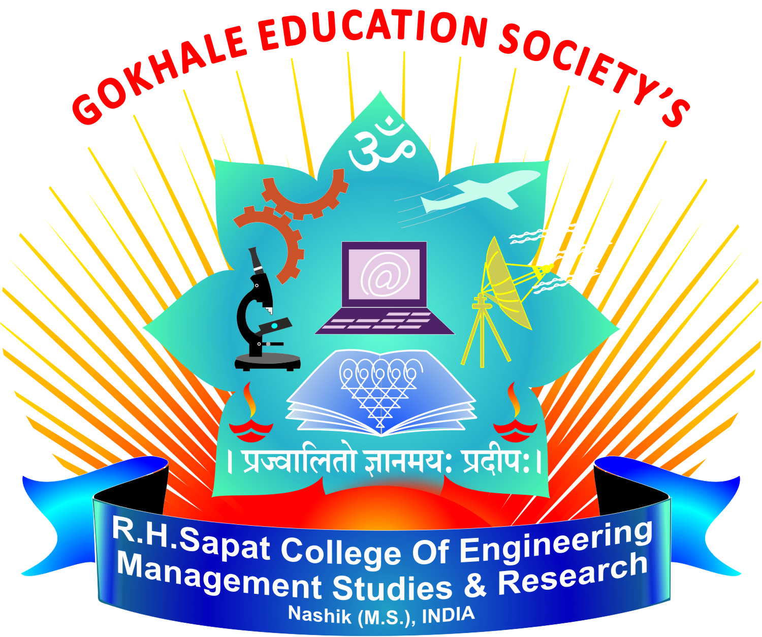 | Gokhale Education Society’s  R. H. Sapat College of Engineering, Management Studies & Research, Nasik-422005  Department of Computer Engineering

CLASS TIME TABLE

Academic Year | 2018-19 | Semester | VI
Department | Computer Engineering | Class | T.E. – B Div.
Class Room | M005 | W.E.F. | 18th Dec. 2018

Class Co-ordinator: Mrs.G.A.Dhamne

Day/Time | Monday | Tuesday | Wednesday |  | Thursday | Friday | Saturday
10.15-11.15 | WT | SPOSL(RDN)-TB1 WTL(SVG) –TB2 ESIOTL(RPC)-TB3 | SPOSL(RDN)-TB2 WTL(SVG) –TB3  SPOSL(GKB)-TB1 |  | SPOSL(RDN)-TB3 ESIOTL(RPC)-TB1  SPOSL(GKB)-TB2 | WTL(SVG) –TB1  ESIOTL(RPC)-TB2  SPOSL(GKB)-TB3 | DAA
11.15-12.15 | SMD |  |  |  |  |  | ESIOT
LUNCH BREAK
1.00-2.00 | ESIOT | WT |  | SMD | SMD | ESIOT | Skill Set Training
2.00-3.00 | SPOS | WT |  | DAA | DAA | SPOS
TEA BREAK
3.15-4.15 | Skill Set Training | ESIOT |  | SPOS | Skill Set Training | Skill Set Training | Dept. Activity
4.15-5.15 |  | DAA |  | SPOS

Theory Practical

DAA | Mr. S. V. Ghorpade |  |  | Batches | Staff | Lab
SPOS | Mrs.R.D.Narwade |  | WTL | TB1, TB2, TB3 | SVG | L204
SMD | Mr.S.R.Jadhav |  | ESIOTL | TB1, TB2, TB3 | RPC | HL-M010
ESIOT | Mr. R. R. Chakre |  | SPOSL | TB1, TB2, TB3 | RDN | ELL
 |  |  |  | TB1, TB2, TB3 | GKB | 303A
WT | Mrs. G. A. Dhamne |  | Skill Set Training | TB1, TB2, TB3 | SVG,SRJ  GAD,RDN | L204,ELL,303A

(Ms.V.S.Nikam) (Dr. D. V. Patil) (Dr. P. C. Kulkarni)
Time Table Coordinator HOD Principal

